Name: ________________________________________________ Core: _______________
Unit 7 Test Review/6+
1. Simplify. You may have to distribute first.
- 8(4 + 3w + 2 + w) E. 4(2q + 5) + 8q + 3 – 3q

- 8x + 3 + 10x – 2x + 11 + 5x F. 12f – 4f + 4h + 10h – 2f + 4f + 3h

- 10(3x + 3p) – 21x + 6p G. 9 + 7h + 15 – 4h – 20 + 8h + 2

- 12(2x + y) + 10x – 6y – 5x H. 3(2m + 3n) + 5(4m + 5n)

2. Which expression is equivalent to 24 + 54x?

A. 9(3 + 6x) B. 4(20 + 50x) C. 2(12 – 27x) D. 6(4 + 9x)

3. Simplify and write an equivalent expression to: 5(3 – x) + 3³
A. 24 – 5x B. 35 – x C. 42 – 5x D. 42 – x

4. Use the distributive property to write an equivalent expression for: 72x + 42

A. 6(12x + 7x) B. 6(12 + 7) C. 6(12x + 7) D. 6(12x – 7)

5. Write in expanded form.
9⁵ __________________________________
1⁴ __________________________________
${(\frac{1}{4})}^{3}$ __________________________________
g⁶ __________________________________

6. Write in exponential form.
8 ● 8 ● 8 ● 8 ● 8 ● 8 ● 8 ___________
p ● p ● p ● p ● p __________
$\frac{7}{8} × \frac{7}{8}$ ___________

7. Substitute the value in for each expression then evaluate.
- 4y + 1 when y = 5 D. 2^{k} • 4 when k = 1

- 5(x + z) when x = 3 and z = 1 E. j² + 4^{m} when j = 3 and m = 2

- 7xy + 3² when x = 2 and y = 3 F. w¹ + 7² + wm when w = 5 and m = 3

8. Jack can text 210 characters in 21 minutes (m). Write an expression for m minutes.
A. 210m B. 10m C. 21m D. 12m
9. A cell phone company charges an activation fee of $120.00 and then $45.00 monthly for a
data plan. Which expression describes this situation.

A. 45x B. 165x C. 120 + 45x D. 120 – 4x

10. Mitchell and 3 of his friends paid $18.00 for lunch. Write an equation to find how much
the total bill cost the group?
A. 3x = 18 B. 4x = 18 C. $\frac{x}{3}=18$ D. $\frac{x}{4}=18$
11. Which expression represents the phrase “10 less than k”?
A. k + 10 B. 10 – k C. 10 + k D. k – 10

12. Match the line with the correct equation.
A)

A. y = 2x + 1 B. y = 3x – 1 C. y = 5x – 5 D. y = 2x + 5

B)
A. $y= \frac{x}{2}$ B. y = 2x – 2 C. $y= \frac{x}{4}$ D. y = 3x

C)

A. y = 2x B. y = 2x + 4 C. y = 5x D. y = 4x

Question # | Dogs | Cats
Giving | 5 | 2
1 | 15
2 |  | 8
3 |  | 4
13. Answer the questions then graph the order pairs. Giving information.
A. There are 2 cats for every 5 dogs.
1. How many cats are there if there are 15 dogs?

2. How many dogs are there if there are 8 cats?

3. How many dogs are there if there are 4 cats

Dogs | Cats | Order Pair
Complete table

Plot the points. Do not connect the points.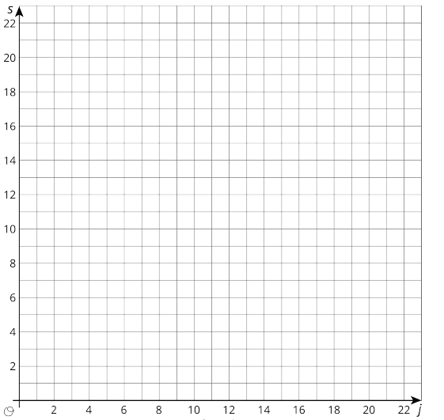
dog (d)
cats (c)

Let “d” represent the dogs and “c” represent the cats. Write an equation that shows a relationship between the dog and cats.
14. Answer the questions then graph the order pairs.
Giving information.
B. In Sue’s trail mix she is combining 2 cups of raisins with 3 cups of dried cranberries.
1. If Sue used 6 cups of raisins how many cups of dried cranberries will she use?
2. If Sue used 15 cups of dried cranberries how many cups of raisins will she use?
3. If Sue used 4 cups of raisins how many cups of dried cranberries will she use?
4. If Sue used 12 cups of dried cranberries how many cups of raisins will she use?

Question # | raisins | cranberries
Giving | 2 | 3
1 | 6
2 |  | 15
3 | 4
4 |  | 12

Complete table.
raisins | cranberries | Order Pair

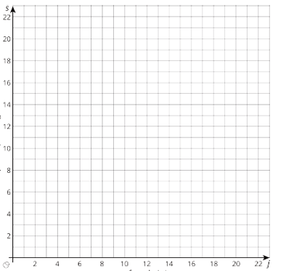
Cups of Cranberries (c)
Cups of Raisins (r)

Let “r” represent raisins and “c” represent cranberries. Write an equation that shows the relationship between the raisins and cranberries.

