6 Unit 1 Mid Unit Review

Name: Core:

Find the area of each figure. Show your set-ups and do not forget about the units.

1. 2.
10 m
27.4 ft
12 m
11 ft

31 m

Area = _________________ Area = __________________

3. 4.
40 cm
60 cm

55 in
52 in
35 cm

25 in

Area = __________________ Area = __________________

16 ft
5. 6.

35.1 in
30.6 in
20 ft
12 ft

10.2 in

Area = __________________ Area = __________________

7. 8.

8 ft

15 ft
28 ft
20 ft
20 ft

23 ft

Area = __________________ Area = ___________________

9. Draw a height that corresponds to each base. Make sure you label it with a “h”.

base
base

base
base

base

base

10. A rectangle has an area or 192 in². If one side is 16 inches what is the measurement of the other side?

11. A parallelogram has an area of 374 in². If the height of the parallelogram is 17 inches what is the base?

12. Draw two parallelograms that have an area of 16 unit². The parallelograms cannot be identical.

13. Draw two rectangles that have an area of 24 unit². The rectangles cannot be identical.

14. Find the area for each parallelogram.

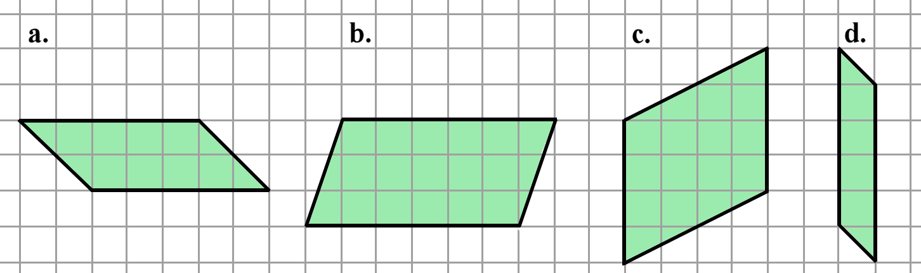

- Area = _______________ c. Area = ________________

- Area = _______________ d. Area = ________________

17. Determine the area of the figure. Explain your reasoning.

Area = ________________

Reasoning:
