**Name: _____________________________________ Core: _________________**

**Unit 1 Review: Surface Area & Volume**

**SHOW YOUR SETUPS FOR ALL THE PROBLEMS.**

1. Find the **surface area** and **volume** of the rectangular prisms.

 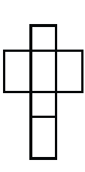

6 m

12 m

5 m

12 in

22 in

35 in

Surface Area = ______________________ Surface Area = ______________________

Volume = __________________________ Volume = ____________________

2. Find the surface areaof the square pyramids. Show your setups.

8 ft

 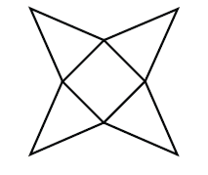

11 ft

Surface Area = ______________________ Surface Area = _______________________

3. Find the surface area each triangular prisms. Show your setups.

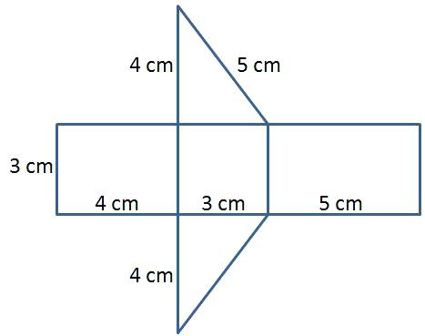 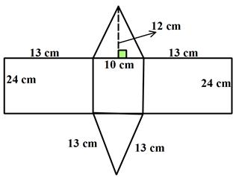

5 ft

10 cm

18 cm

Surface Area = __________________ Surface Area = ____________________

4. Find the surface **area** and **volume** of each cube. Show your setups and do not forget your units.

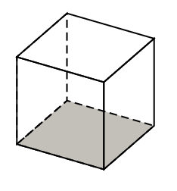 

44 in

8 in

Surface Area = _______________ Surface Area = ________________

Volume = ___________________ Volume = ____________________

5. Find the surface area and volume of each cube.

|  |  |  |  |
| --- | --- | --- | --- |
| Solid Figure | Side length | Surface Area (ft2) | Volume (ft3) |
| A. Cube | 16 ft |  |  |
| B. Cube | 5 ft |  |  |
| C. Cube | * 1. ft |  |  |

Setups: Surface Area Setups: Volume

1. ____________________________________ ____________________________________
2. ____________________________________ ____________________________________
3. ____________________________________ ____________________________________

6. Find the surface area and volume for each rectangular prism. Show your setups.

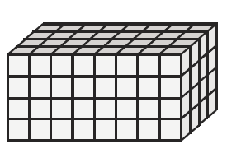 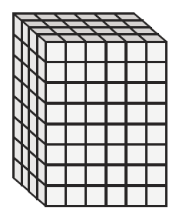

Volume = ________________ Volume = _______________

SA = __________________ SA = ___________________

|  |  |  |
| --- | --- | --- |
| 7. Find the area of each square. | | |
| Figure | Side length (in) | Area (in2) |
| Square | 34 |  |
| Square | 4.5 |  |
| Square | 18 |  |
| 8. Find the side length for each giving area. | | |
| Figure | Area(cm2) | Side length (cm) |
| Square | 144 |  |
| Square | 49 |  |
| Square | 64 |  |
| Square | 16 |  |

Solve. Show your setups.

9. A cereal box has dimensions of 4 inches wide, 12 inches length and 15 inches high. What is the surface area

of the box?

10. A square has an area of 100 in2. What is the side length of the square?

11. A square has an area of 81 ft2. What is the side length of the square?

12. A square has a side length of 15 feet. What is the area?

13. A square has a side length of 18 inches. What is the area?

14. Name each polyhedron.

|  |  |  |  |
| --- | --- | --- | --- |
| a. |  | c. |  |
| b. |  | d. |  |

1. _____________________________ c. ______________________________
2. _____________________________ d. ______________________________

15. Circle the greatest number for each pair.

1. 9 ● 24 or 52● 33
2. 34 or 24 ● 3

1. 53 ● 4 or 43 ● 3
2. 10 ● 23 or 63● 13
3. 24 ● 2 or 25 ● 22

1. 91 ● 7 or 80 ● 60

16. With 9 cubes create a 3 by 3 by 3 cube and determine the surface area.

Drawing of your 3 by 3 by 3 cube:

Surface area = ________________

Take any one of the 9 cube away so now you only have 8 cubes. Determine the surface area.

Drawing of your figure.

Surface area = ________________

Take another one of the cubes away so now you only have 7 cubes. Determine the surface area.

Drawing of your figure.

Surface area = ________________

17.

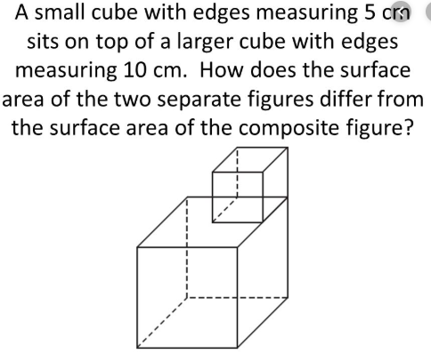

SA of small cube = ________________

SA of larger cube = ________________

Total surface area of the combined 2 cubes = _________________

Total surface area of the combined figure = __________________