**Name: _____________________________________ Core: _________________**

**Unit 1 Review: Surface Area & Volume**

1. Find the **surface area** and **volume** of the rectangular prisms. Show your setups.

 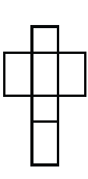

6 m

12 m

5 m

12 in

22 in

35 in

Surface Area = ______________________ Surface Area = ______________________

Volume = __________________________ Volume = __________________________

2. Find the surface areaof the square pyramids. Show your setups.

8 ft

 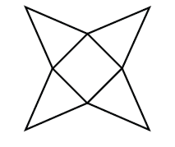

11 ft

Surface Area = ______________________ Surface Area = _______________________

1. Find the surface area of the triangular prisms. Show your setups.

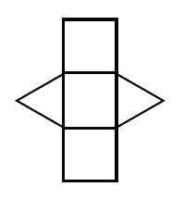 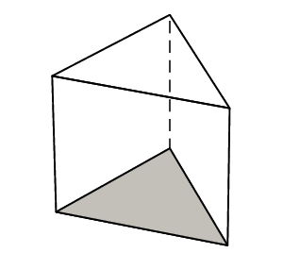

3 ft

4 ft

5 ft

14 cm

10 cm

17 cm

18 cm

Surface Area = __________________ Surface Area = ____________________

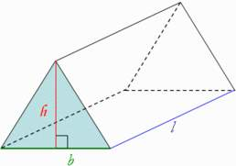 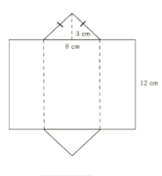

8 in

44 in

20 in

Surface Area = __________________ Surface Area = ____________________

1. Name each polyhedron giving their nets.

|  |  |  |  |
| --- | --- | --- | --- |
| a. |  | c. |  |
| b. |  | d. |  |

1. _____________________________ c. ______________________________
2. _____________________________ d. ______________________________
3. Find the surface area and volume for each rectangular prism. Show your setups.

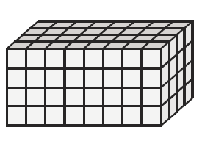 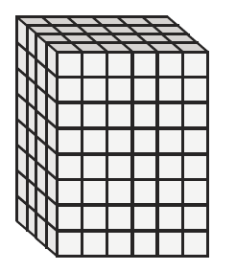

Volume = ________________ Volume = _______________

SA = __________________ SA = ___________________

1. Sandra painted her bedroom. Her room is in the shape of a rectangular prism 15 feet long, 12 feet wide and 10 feet tall. If she paints everything but the floor how much surface area does Sandra paint?
2. Find the **surface area** and **volume** of each cube.

|  |  |  |  |
| --- | --- | --- | --- |
| Solid Figure | Side length | Surface Area (ft2) | Volume (ft3) |
| A. Cube | 16 ft |  |  |
| B. Cube | 5 ft |  |  |
| C. Cube | * 1. ft |  |  |

Setups: Surface Area Setups: Volume

1. ____________________________________ ____________________________________
2. ____________________________________ ____________________________________
3. ____________________________________ ____________________________________

|  |  |  |
| --- | --- | --- |
| 9. Find the area of each square. | | |
| Figure | Side length (in) | Area (in2) |
| Square | 34 in |  |
| Square | 4.5 in |  |
| Square | 18 in |  |
| 10. Find the side length for each giving area. | | |
| Figure | Area(cm2) | Side length (cm) |
| Square | 144cm2 |  |
| Square | 225cm2 |  |
| Square | 64cm2 |  |

11. Which figure has a greater surface area? What is the surface area of each? Each edge is 1

centimeter in measurement.

# 1 surface area = ________________

#2 surface area = _________________

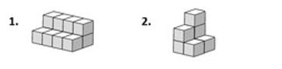

12.

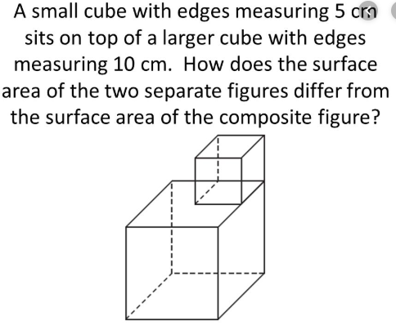

1. Surface area of small cube = ___________________________

2. Surface area of the larger cube = _______________________

* Total surface area = _________________________

1. Surface area of the original composite figure = ____________________

Why is one of the surface areas less than the other?