**Independent and Dependent Variables Notes**

**Independent variable ~** is a variable in an equation where its values can be any number.

* **Any value can be chosen for** **x**
* **Independent variables change.**
* **Also known as “Input”.**

Example: y = 4***x*** + 2 ------- **x** is the **independent** **variable** because **x** can be any value you choose for it.

If x = **2** then y = 4 • 2 + 2 so y = **10**

If x = **4** then y = 4 • 4 + 2 so y = **18**

These values of input create values of output. Together they are called an order pair: (2, 10), (4, 18). These order pairs are points that are on the same line.

**Dependent variable ~** is a variable whose value depends on the other variable. (It depends on the independent variable)

Example: **y** = 2x + 8

* **The “y” is dependent because it depends on the number chosen for x.**
* **You cannot figure out “y” until you know what “x” is.**
* **Also known as “Output”.**

**\*\*\*\*\*\*\*\*Bottom line is that the solutions for the equation (Which is the “y”) depends on the chosen value for x.**

Example: This type of table is called a **Function Table** or an **Input/Output Table.**

What you get out (y) depends on what you put in (x).

|  |  |  |  |
| --- | --- | --- | --- |
| Equation | Input (x) | Output (y) | Order Pair ( x, y ) |
| y = 3x + 2 | 4 | 3 • 4 + 2 = 14 | (4, 14) |
| y = 3x + 2 | 0 | 3 • 0 + 2 = 2 | (0, 2) |
| y = 5x | 1 | 5 • 1 = 11 | (1, 5) |
| y = 5x | 0 | 5 • 0 = 0 | (0, 0) |

Practice: 1 independent dependent

|  |  |  |  |
| --- | --- | --- | --- |
| Equation | Input (x) | Output (y) | Order Pair ( ) |
| y = 4x + 5 | 2 |  |  |
| y = 4x + 5 | 0 |  |  |
| y = 9x | 2 |  |  |
| y = 9x | 0 |  |  |

Practice: 2 independent dependent

|  |  |  |  |
| --- | --- | --- | --- |
| Equation | Input (x) | Output (y) | Order Pair ( ) |
| y = x + 6 | 20 |  |  |
| y = x + 6 | 0 |  |  |
| y = 2x | 10 |  |  |
| y = 2x | 0 |  |  |

Practice: 3 independent dependent

|  |  |  |  |
| --- | --- | --- | --- |
| Equation | Input (m) | Output (n) | Order Pair ( ) |
| n = 6m + 1 | 4 |  |  |
| n = 6m + 1 | 0 |  |  |
| n = 8m | 2 |  |  |
| n = 8m | 0 |  |  |

Practice: 4 independent dependent

|  |  |  |  |
| --- | --- | --- | --- |
| Equation | Input (a) | Output (b) | Order Pair ( ) |
| b = 2a + 2 | 2 |  |  |
| b = 2a + 2 | 0 |  |  |
| b = a | 3 |  |  |
| b = a | 0 |  |  |

Practice: 5 independent dependent

|  |  |  |  |
| --- | --- | --- | --- |
| Equation | Input (x) | Output (y) | Order Pair ( ) |
| y = 7x + 1 | 3 |  |  |
| y = 7x + 1 | 0 |  |  |
| y = 5x | 7 |  |  |
| y = 5x | 0 |  |  |

Practice: 6 independent dependent

|  |  |  |  |
| --- | --- | --- | --- |
| Equation | Input (g) | Output (h) | Order Pair ( ) |
| h = 2g + 10 | 11 |  |  |
| h = 2g + 10 | 0 |  |  |
| h = 11g | 3 |  |  |
| h = 11g | 0 |  |  |

Practice: 7 independent dependent

|  |  |  |  |
| --- | --- | --- | --- |
| Equation | Input (p) | Output (q) | Order Pair ( ) |
| q = p + 8 | 4 |  |  |
| q = p + 8 | 0 |  |  |
| q = 6p | 9 |  |  |
| q = 6p | 0 |  |  |

Practice: 8 independent dependent

|  |  |  |  |
| --- | --- | --- | --- |
| Equation | Input (x) | Output (y) | Order Pair ( ) |
| y = 3x + 8 | 15 |  |  |
| y = 3x + 8 | 0 |  |  |
| y = 8x | 2 |  |  |
| y = 8x | 0 |  |  |

**Input Output Tables and Graphs**

Complete each table then graph.

**EXAMPLE**

Equation: y = 2x + 1

y = 2 ● 0 + 1/ y = 1

y = 2 ● 1 + 1/ y = 3

y = 2 ● 3 + 1/ y = 7

y = 2 ● 4 + 1/ y = 9



|  |  |  |  |  |
| --- | --- | --- | --- | --- |
| Input (x) | 0 | 1 | 3 | 4 |
| Output (y) | 1 | 3 | 7 | 9 |
| Order Pair | (0, 1) | (1, 3) | (3, 7) | (4, 9) |

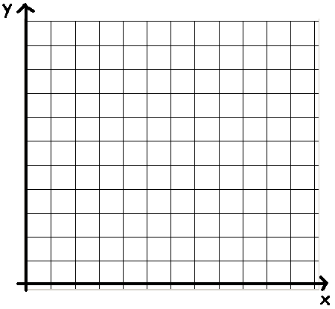

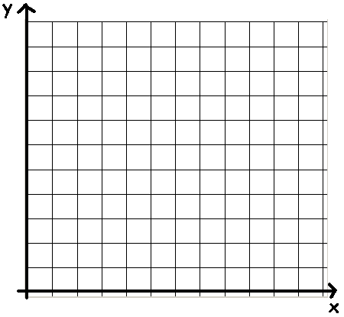

Equation: y = 3x – 4



|  |  |  |  |  |
| --- | --- | --- | --- | --- |
| Input (x) | 0 | 1 | 2 | 4 |
| Output (y) |  |  |  |  |
| Order Pair |  |  |  |  |

Equation:



|  |  |  |  |  |
| --- | --- | --- | --- | --- |
| Input (x) | 2 | 4 | 8 | 10 |
| Output (y) |  |  |  |  |
| Order Pair |  |  |  |  |

Equation: y = 3x + 1



|  |  |  |  |  |
| --- | --- | --- | --- | --- |
| Input (x) | 0 | 1 | 2 | 3 |
| Output (y) |  |  |  |  |
| Order Pair |  |  |  |  |

Equation: y = 2x



|  |  |  |  |  |
| --- | --- | --- | --- | --- |
| Input (x) | 0 | 1 | 3 | 5 |
| Output (y) |  |  |  |  |
| Order Pair |  |  |  |  |

Equation: y = 2x – 2



|  |  |  |  |  |
| --- | --- | --- | --- | --- |
| Input (x) | 1 | 2 | 4 | 6 |
| Output (y) |  |  |  |  |
| Order Pair |  |  |  |  |

Answer the questions then graph the order pairs.

**EXAMPLE**

Giving information

**There are 3 boys for every 4 girls on the playground.**

1. How many girls are there if there are 6 boys?

2. How many boys are there if there are 12 girls?

3. How many girls are there if there are 12 boys?

4. How many boys are there if there are 20 girls?

|  |  |  |
| --- | --- | --- |
| Question # | boys | girls |
| Giving | 3 | 4 |
| 1 | 6 |  |
| 2 |  | 12 |
| 3 | 12 |  |
| 4 |  | 20 |

|  |  |  |
| --- | --- | --- |
| Boys | girls | Order Pair |
| 3 | 4 | (3, 4) |
| 6 | **8** | (6, 8) |
| **9** | 12 | (9, 12) |
| 12 | **16** | (12, 16) |
| **15** | 20 | (15, 20) |

Plot the points. Do not connect the points.

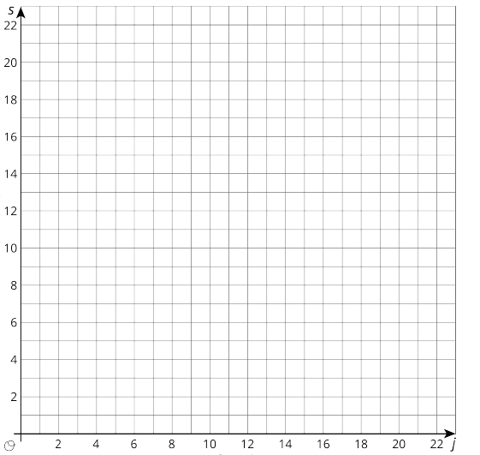

girls (g)

boys (b)

Let “b” represent the boys and “g” represent the girls. Write an equation that shows a relationship between the boys and girls.

Answer the questions then graph the order pairs.

Giving information

**There are 2 red blocks for every 4 blue blocks.**

1. How many red blocks are there if there are 8 blue blocks?

2. How many blue blocks are there if there are 6 red blocks?

3. How many blue blocks are there if there are 8 red blocks?

4. How many red blocks are there if there are 20 blue blocks?

|  |  |  |
| --- | --- | --- |
| Question # | red | blue |
| Giving | 2 | 4 |
| 1 |  | 8 |
| 2 | 6 |  |
| 3 | 8 |  |
| 4 |  | 20 |

Complete table.

|  |  |  |
| --- | --- | --- |
| Red | blue | Order Pair |
|  |  |  |
|  |  |  |
|  |  |  |
|  |  |  |
|  |  |  |

Plot the points. Do not connect the points.



blue (b)

red (r)

1. Let “r” represent the red blocks and “b” represent the blue blocks. Write an equation that shows a relationship between the red and blue blocks.

Answer the questions then graph the order pairs.

Giving information

**There is 1 piece of gum for 3 suckers.**

1. How many suckers are there if there are 3 pieces of gum?

2. How many suckers are there if there are 2 pieces of gum?

3. How many pieces of gum are there if there are 12 suckers?

4. How many pieces of gum there if there are 18 suckers?

|  |  |  |
| --- | --- | --- |
| Question # | gum | sucker |
| Giving | 1 | 3 |
| 1 | 3 |  |
| 2 | 2 |  |
| 3 |  | 12 |
| 4 |  | 18 |

|  |  |  |
| --- | --- | --- |
| Gum | suckers | Order Pair |
|  |  |  |
|  |  |  |
|  |  |  |
|  |  |  |
|  |  |  |

Complete table.

Plot the points. Do not connect the points.



suckers (s)

gum (g)

1. Let “g” represent the gum and “s” represent the suckers. Write an equation that shows a relationship between the gum and the suckers.

Answer the questions then graph the order pairs.

Giving information

**There are 2 books for every 3 videos.**

1. How many videos are there if there are 6 books?

2. How many books are there if there are 9 videos?

3. How many books are there if there are 15 videos?

4. How many videos are there if there are 14 books?

|  |  |  |
| --- | --- | --- |
| Question # | books | videos |
| Giving | 2 | 3 |
| 1 | 6 |  |
| 2 |  | 9 |
| 3 |  | 15 |
| 4 | 14 |  |

|  |  |  |
| --- | --- | --- |
| Red | blue | Order Pair |
|  |  |  |
|  |  |  |
|  |  |  |
|  |  |  |
|  |  |  |

Complete table.

Plot the points. Do not connect the points.



videos (v)

books (b)

1. Let “b” represent the books and “v” represent the videos. Write an equation that shows a relationship between the books and videos.