Function Tables

Directions:
Translate each statement into a mathematical equation, and then complete the function table:

1. y is equal to two more than the product of x and 3.

Mathematical translation:

____________________________________________

Complete the table of values:

x | Y
0
1
2
3

2. y is equal to three less than the product of 2 and x.

Mathematical translation:

_______________________________________________

Complete the table of values:

x | Y
3
4
5
6

3. y is equal to the quotient of x and 2.

Mathematical translation:

_______________________________________________

Complete the table of values:

x | Y
0
2
4
6

4. y is equal to two less than the sum of 2 and x.

Mathematical translation:

_______________________________________________

Complete the table of values:

x | Y
0
1
2
3

5. y is equal to one more than the product of 2 and x.

Mathematical translation:

_______________________________________________

Complete the table of values:

x | Y
0
1
2
3
For each of the next problems match the line with the equation.

1.

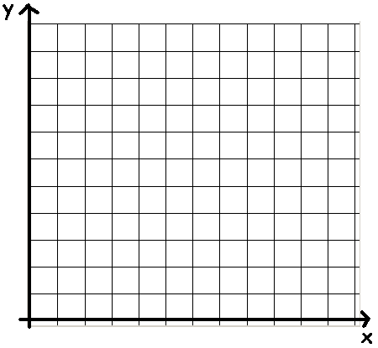

A. y = 2x + 2 B. y = 3x C. y = 4x – 2 D. y = x + 4

2.

A. y = x + 2 B. y = 2x C. y = 6x – 10 D. y = 5x

3.

A. $y= \frac{x}{3}+1$ B. $y= x+1$ C. $y= \frac{x}{2}$ D. $y= 2x-4$

4.

A. y = 2x B. y = 3x - 4 C. y = x + 2 D. y = x

5.

A. $y= \frac{x}{4}+\frac{1}{2}$ B. $y= x-1$ C. $y= \frac{x}{2 }+1$ D. $y= 3x-5$

6

A. y = 4x - 3 B. y = 3x C. y = 2x + 1 D. y = x – 3

Activity: Amusement Park Problem

An amusement park charges $1.50 per ride and an additional $10 to get into the park.

Let x = the number of rides you ride and y = the total cost.

Write an equation for this situation:

_________________________________________

Now create a table of values with at least four x and y values using this equation:

x | y

Graph the points above. What relationship is there between x and y?

Activity: Car Wash Problem

Jake is volunteering at a car wash to help raise money for his school. They are charging $5.00 per car.

Let x = the number of cars and y = the amount of money raised

Write an equation from the information above.

__________________________________________

Complete the table of values below using your equation.

x | y
0
1
2
3

Use your points to graph your equation. What is the relationship between x and y?

_______________________________________________________

